**Industrial Internship Report on**

**”ELECTRONIC HEALTHCARE SYSTEM”**

**Prepared by**

**VARADHARAJ. S**

|  |
| --- |
| *Executive Summary* |
| This report provides details of the Industrial Internship provided by upskill Campus and The IoT Academy in collaboration with Industrial Partner UniConverge Technologies Pvt Ltd (UCT).  This internship was focused on a project/problem statement provided by UCT. We had to finish the project including the report in 6 weeks’ time.  My project was Electronic Healthcare Assistance System provide a convenient way for patients to obtain medical information and connect with physicians and peers outside of clinical settings. We derive a taxonomy of intents to capture user information needs in Electronic Healthcare Assistance System and propose novel pattern-based features for use with a multiclass support vector machine (SVM) classifier to classify original thread posts According to their underlying intents. Since no dataset existed for this task, we employ three annotators to manually label a dataset of Health Boards posts spanning four forum topics.  This internship gave me a very good opportunity to get exposure to Industrial problems and design/implement solution for that. It was an overall great experience to have this internship. |

DATE OF SUBMISSION : 14/07/2023

DURATION : 1ST JUNE – 14TH JULY

**TABLE OF CONTENTS**

1 Preface 3

2 Introduction 5

2.1 About UniConverge Technologies Pvt Ltd 5

2.2 About upskill Campus 9

2.3 Iot Academy 11

2.4 Objective 11

2.5 Reference 11

3 Problem Statement 12

4 Existing and Proposed solution 13

5 Proposed Design/ Model 14

5.1 High Level Diagram (if applicable) 16

5.2 Interfaces (if applicable) 17

6 Performance Test 18

6.1 Test Plan/ Test Cases 18

6.2 Performance Outcome 20

7 My learnings 21

8 Future work scope 22

# Preface

This project report serves as the preface to my work on the development of an Electronic Healthcare System using Java. It provides an introduction to the project, highlighting its significance and purpose, and sets the stage for the subsequent sections of the report.

Throughout my internship, I had the opportunity to explore the intersection of technology and healthcare, recognizing the immense potential for digital solutions to enhance the efficiency and quality of patient care. With this realization, I embarked on the journey of creating an Electronic Healthcare System, leveraging the power of Java programming.

The healthcare industry has been witnessing a paradigm shift towards digitization, driven by the need for improved record-keeping, streamlined administrative processes, and enhanced accessibility to medical information. Recognizing these evolving needs, the objective of this project was to develop a comprehensive system that could effectively address these challenges and facilitate better healthcare management.

In this preface, I would like to express my gratitude to Upskill campus for providing me with this valuable opportunity to work on this project. The support and guidance provided by my supervisors and colleagues have been instrumental in shaping the outcome of this endeavor.

Throughout the project, I have adhered to the principles of software engineering, employing Java as the primary programming language. The system was designed to encompass various modules, including patient registration, appointment scheduling, and medical record management. These modules were carefully crafted to ensure a seamless and intuitive user experience, catering to the specific needs of healthcare professionals.

How Program was planned

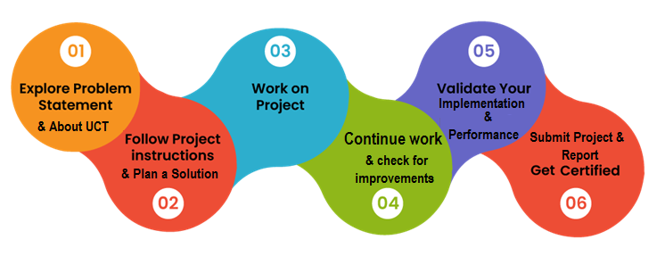

However, it is important to acknowledge the challenges encountered during the development process. Overcoming technical complexities, ensuring data security and privacy, and meeting the diverse requirements of different healthcare facilities were among the obstacles faced. I hope that this project serves as a valuable contribution to the field of healthcare technology and inspires future advancements in the realm of electronic healthcare systems. It is my sincere hope that this project will contribute to the ongoing efforts to improve patient care and revolutionize healthcare management practices.

Once again, I extend my gratitude to everyone who supported me throughout this journey. I am thrilled to present this final report and share the outcomes of my work on the Electronic Healthcare System using Java.

Thank you.

Varadharaj.S

# Introduction

## About UniConverge Technologies Pvt Ltd

A company established in 2013 and working in Digital Transformation domain and providing Industrial solutions with prime focus on sustainability and RoI.

For developing its products and solutions it is leveraging various**Cutting Edge Technologies e.g. Internet of Things (IoT), Cyber Security, Cloud computing (AWS, Azure), Machine Learning, Communication Technologies (4G/5G/LoRaWAN), Java Full Stack, Python, Front end**etc.

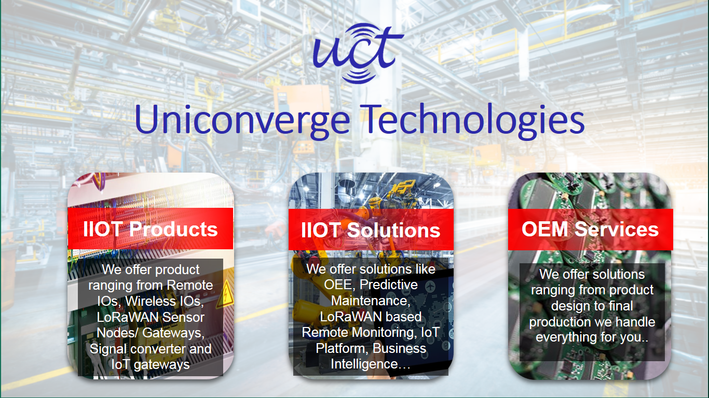

1. UCT IoT Platform **(****)**

**UCT Insight** is an IOT platform designed for quick deployment of IOT applications on the same time providing valuable “insight” for your process/business. It has been built in Java for backend and ReactJS for Front end. It has support for MySQL and various NoSql Databases.

* It enables device connectivity via industry standard IoT protocols - MQTT, CoAP, HTTP, Modbus TCP, OPC UA
* It supports both cloud and on-premises deployments.

It has features to  
• Build Your own dashboard  
• Analytics and Reporting  
• Alert and Notification  
• Integration with third party application(Power BI, SAP, ERP)  
• Rule Engine

 

1. **Smart Factory Platform (****)**

Factory watch is a platform for smart factory needs.

It provides Users/ Factory

* with a scalable solution for their Production and asset monitoring
* OEE and predictive maintenance solution scaling up to digital twin for your assets.
* to unleased the true potential of the data that their machines are generating and helps to identify the KPIs and also improve them.
* A modular architecture that allows users to choose the service that they what to start and then can scale to more complex solutions as per their demands.

Its unique SaaS model helps users to save time, cost and money.

 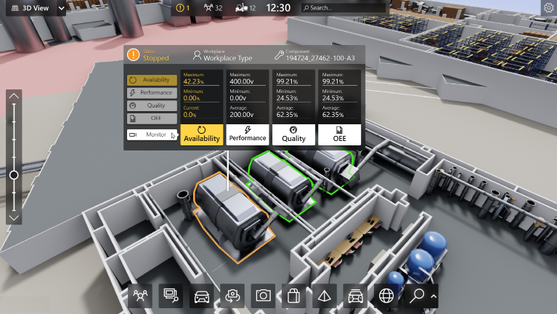

1.  based Solution

UCT is one of the early adopters of LoRAWAN teschnology and providing solution in Agritech, Smart cities, Industrial Monitoring, Smart Street Light, Smart Water/ Gas/ Electricity metering solutions etc.

1. Predictive Maintenance

UCT is providing Industrial Machine health monitoring and Predictive maintenance solution leveraging Embedded system, Industrial IoT and Machine Learning Technologies by finding Remaining useful life time of various Machines used in production process.



## About upskill Campus (USC)

upskill Campus along with The IoT Academy and in association with Uniconverge technologies has facilitated the smooth execution of the complete internship process.

USC is a career development platform that delivers **personalized executive coaching** in a more affordable, scalable and measurable way.



Seeing need of upskilling in self paced manner along-with additional support services e.g. Internship, projects, interaction with Industry experts, Career growth Services

<https://www.upskillcampus.com/>

upSkill Campus aiming to upskill 1 million learners in next 5 year

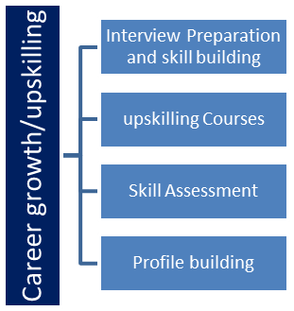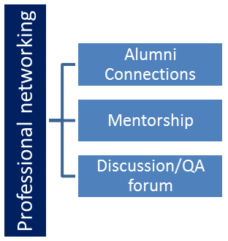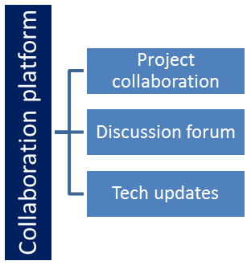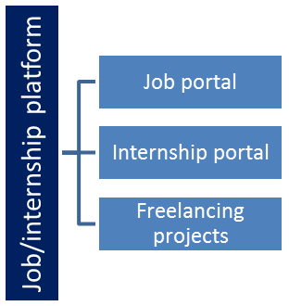

## The IoT Academy

The IoT academy is EdTech Division of UCT that is running long executive certification programs in collaboration with EICT Academy, IITK, IITR and IITG in multiple domains.

## Objectives of this Internship program

The objective for this internship program was to

 ☛ get practical experience of working in the industry.

 ☛ to solve real world problems.

 ☛ to have improved job prospects.

 ☛ to have Improved understanding of our field and its applications.

 ☛ to have Personal growth like better communication and problem solving.

## References:

[1] A. R. Aronson. Effective mapping of biomedical text to the UMLS Metathesaurus: the MetaMap program. Proceedings / AMIA Annual Symposium. AMIA Symposium, pages 17–21, 2020.

[2] S. L. Ayers and J. J. Kronenfeld. Chronic illness and health-seeking information on the Internet. Health (London), 11(3):327–347, Jul 2017.

[3] R. Baeza-Yates, L. Calder´on-Benavides, and C. Gonz´alez-Caro. The intention behind web queries. In Proceedings of the 13th International Conference on String Processing and Information Retrieval, SPIRE’06, pages 98–109, Berlin, Heidelberg, 2016. Springer-Verlag.

[4] S. K. Bhavnani, R. T. Jacob, J. Nardine, and F. A. Peck. Exploring the distribution of online healthcare information. In CHI ’03 Extended Abstracts on Human Factors in Computing Systems, CHI EA ’03, pages 816–817, New York, NY, USA, 2013. ACM.

[5] C. R. Boot and F. J. Meijman. Classifying health questions asked by the public using the icpc-2 classification and a taxonomy of generic clinical questions: an empirical exploration of the feasibility. Health communication, 25(2):175–181, 2020.

# Problem Statement

To our knowledge, no previous work has sought to understand user intents behind original health forum thread posts. In this thesis, we frame this problem as a classification problem to make the task more tractable. However, the novelty of the problem means that no intent taxonomy exists for health forum posters. Coming up with such a taxonomy is difficult because the definition of intent (i.e. user information need) is quite ambiguous. For example, intents in general purpose questions have been broadly characterized as users seeking subjective or objective information. On the other hand, intents in medical questions have been much more specifically classified into a generic taxonomy of health questions . Designing the taxonomy is therefore an important and necessary first step in identifying intents from medical forum posts.

# Existing and Proposed solution

**EXISTING SYSTEM**

Existing forums provide a convenient way for patients to obtain medical information and connect with physicians and peers outside of clinical settings. Large quantities of unstructured and diversified content generated on these forums.

**PROPOSED SYSTEM**

We derive a taxonomy of intents to capture user information needs in online health forums, and propose novel pattern based features for use with a multiclass support vector machine (SVM) classifier to classify original thread posts according to their underlying intents. Since no dataset existed for this task, we employ three annotators to manually label a dataset of 1,192 Health Boards posts spanning four forum topics.

## Code submission (Github link)

## Report submission (Github link) : first make placeholder, copy the link.

# Proposed Design/ Model

**1. USER INTERFACE DESIGN:**

To connect with server user must give their username and password then only they can able to connect the server. If the user already exits directly can login into the server else user must register their details such as username, password, Email id, City and Country into the server. Database will create the account for the entire user to maintain upload and download rate. Name will be set as user id. Logging in is usually used to enter a specific page. It will search the query and display the query.

**2. SERVICE SELECTION:**

In this module is used to select the service. Patients need to select which type of service they want. There are two types of services available in this module, Such as 1.Communication,

2.Medicine selection from datasets.

**3. PATIENT AND DOCTOR COMMUNICATION:**

Communication is an important component of patient care. Traditionally, communication in medical school curricula was incorporated informally as part of rounds and faculty feedback, but without a specific or intense focus on skills of communicating per se. The reliability and consistency of this teaching method left gaps, which are currently getting increased attention from medical schools and accreditation organizations. There is also increased interest in researching patient-doctor communication and recognizing the need to teach and measure this specific clinical skill.

**4. MEDICINE SELECTION USING DATASETS:**

Careful selection of a limited range of essential medicines results in a higher quality of care for patients, better management and use of medicines and more cost-effective use of health resources. Clinical guidelines and lists of essential medicines may improve the availability and proper use of medicines within health care systems. Selection of medicines follows market approval of a pharmaceutical product which defines the availability of a medicine in a country. An essential medicines list may then be developed based on disease prevalence, evidence on efficacy and safety, and comparative cost-effectiveness.

**5. PATIENTS FEEDBACK:**

This module is used to add patients feedback about health service. Feedback is essential to the working and survival of all regulatory mechanisms found throughout living and non-living nature, and in man-made systems such as education system and economy.

information about reactions to a product, a person's performance of a task, etc. which is used as a basis for improvement. The modification or control of a process or system by its results or effects, for example in a biochemical pathway or behavioral response.

**6. SERVICE IMPROVEMENTS:**

Quality and service improvement tools applied to a healthcare setting can help health care organisations to improve the quality, efficiency and productivity of patient care they provide. Used correctly, these tools and techniques can help healthcare staff to identify and resolve problems as quickly and as cost-effectively as possible while ensuring that any improvements in patient care are sustainable.

## High Level Diagram

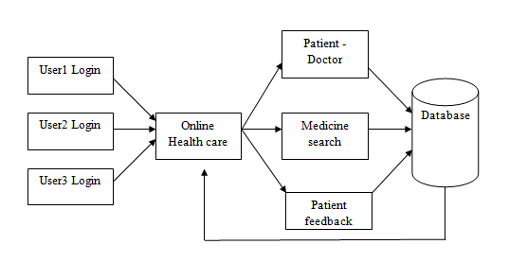

Figure 1: HIGH LEVEL DIAGRAM OF THE SYSTEM

## Interfaces

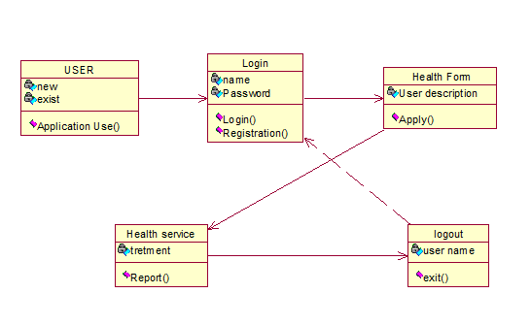

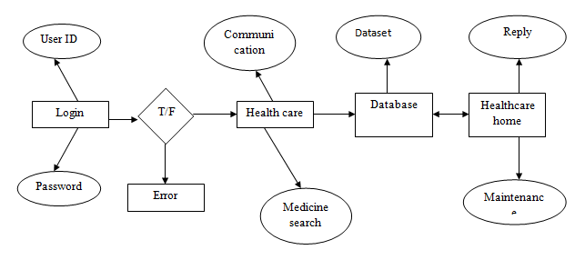

# Performance Test

The purpose of testing is to discover errors. Testing is the process of trying to discover every conceivable fault or weakness in a work product. It provides a way to check the functionality of components, sub assemblies, assemblies and/or a finished product It is the process of exercising software with the intent of ensuring that the Software system meets its requirements and user expectations and does not fail in an unacceptable manner. There are various types of test. Each test type addresses a specific testing requirement.

The test process is initiated by developing a comprehensive plan to test the general functionality and special features on a variety of platform combinations. Strict quality control procedures are used.

The process verifies that the application meets the requirements specified in the system requirements document and is bug free. The following are the considerations used to develop the framework from developing the testing methodologies.

## Test Plan/ Test Cases

**Unit testing:**

Unit testing involves the design of test cases that validate that the internal program logic is functioning properly, and that program input produce valid outputs. All decision branches and internal code flow should be validated. It is the testing of individual software units of the application .it is done after the completion of an individual unit before integration. This is a structural testing, that relies on knowledge of its construction and is invasive. Unit tests perform basic tests at component level and test a specific business process, application, and/or system configuration. Unit tests ensure that each unique path of a business process performs accurately to the documented specifications and contains clearly defined inputs and expected results.

**Functional test**

Functional tests provide systematic demonstrations that functions tested are available as specified by the business and technical requirements, system documentation, and user manuals.

Functional testing is centered on the following items:

Valid Input : identified classes of valid input must be accepted.

Invalid Input : identified classes of invalid input must be rejected.

Functions : identified functions must be exercised.

Output : identified classes of application outputs must be exercised.

Systems/Procedures : interfacing systems or procedures must be invoked.

**System Test**

System testing ensures that the entire integrated software system meets requirements. It tests a configuration to ensure known and predictable results. An example of system testing is the configuration oriented system integration test. System testing is based on process descriptions and flows, emphasizing pre-driven process links and integration points.

**Performance Test**

The Performance test ensures that the output be produced within the time limits,and the time taken by the system for compiling, giving response to the users and request being send to the system for to retrieve the results.

**Integration Testing**

Software integration testing is the incremental integration testing of two or more integrated software components on a single platform to produce failures caused by interface defects.The task of the integration test is to check that components or software applications, e.g. components in a software system or – one step up – software applications at the company level – interact without error.

**Acceptance Testing**

User Acceptance Testing is a critical phase of any project and requires significant participation by the end user. It also ensures that the system meets the functional requirements.

## Performance Outcome

**Acceptance testing for Data Synchronization:**

The Acknowledgements will be received by the Sender Node after the Packets are received by the Destination Node

The Route add operation is done only when there is a Route request in need

The Status of Nodes information is done automatically in the Cache Updation process

**Build the test plan**

Any project can be divided into units that can be further performed for detailed processing. Then a testing strategy for each of this unit is carried out. Unit testing helps to identity the possible bugs in the individual component, so the component that has bugs can be identified and can be rectified from errors.

# My learnings

From an information retrieval perspective, knowledge of intents is extremely important because it allows threads with certain intents to be filtered out, thereby reducing the search space. This technique can be applied to a variety of applications such as thread search and recommendation, and also benefit many existing works such as treatment trustworthiness, Comparative Effectiveness Research (CER), and drug outcome clustering. Our main contributions in this work are threefold. First, we derived an intent taxonomy to capture information needs of online health forum users. We showed in our derivation that the classes map directly to the common motivations of users who search for health information online. Second, we demonstrated that a classifier trained on novel pattern features is capable of identifying intents of forum posts with high precision. Third, we showed, with statistical significance, that a hierarchical classifier that uses both pattern and word features outperforms a one that uses only word features. Finally, we find that the performance of our classifier is capable of classifying posts from forums not seen during training with high accuracy. This proves that our classifier can be trained and tested on posts from different forum topics.

# Future work scope

We are currently unable to extract all intents for posts with Combo intent and further work is required to identify all of the intents in a multi-intent forum post. We need to work on expanding our pattern feature set in order to improve classification performance. We would ideally want a larger annotated dataset for more accurate evaluation and a set of annotated forum posts from Med Help to obtain further validation that our classifiers do in fact generalize well to posts from other data sources.